- Find the equation of the line tangent to the given curve at the point .
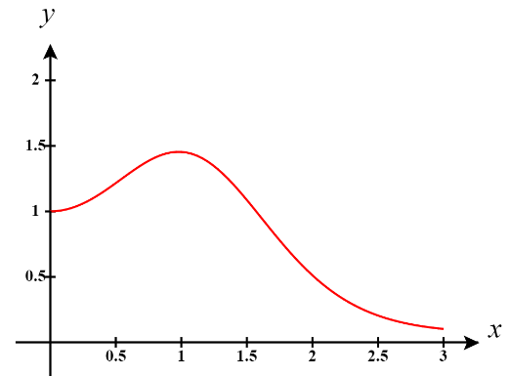
- True or False? The tangent line to the function (shown below) is horizontal when .

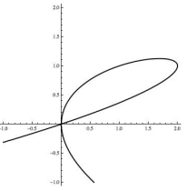
- The following is the graph of . There are two points on the graph where . Determine the equation of both tangent lines to the graph where .

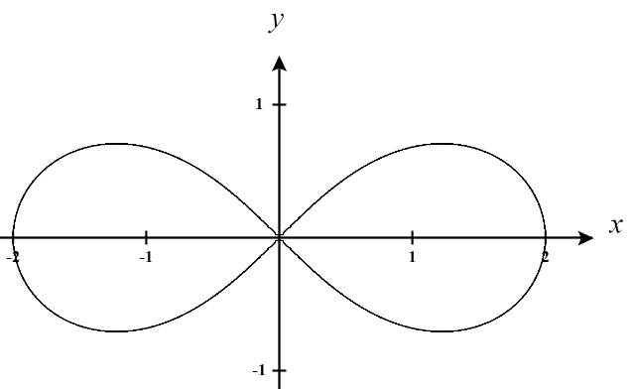
- The lemniscate shown below is described by the equation and is used in typography to denote infinity
- Find for points on the graph.

- Are there any points on the curve for which is undefined? If so, find all such points.

- Determine the equation for the tangent line at the point

- Consider a circle centered at the origin with radius r.
- If , show that the tangent line at the point is perpendicular to the radius of the circle.
- Show that for a circle of any radius that the tangent line at the point is perpendicular to the radius of the circle.

